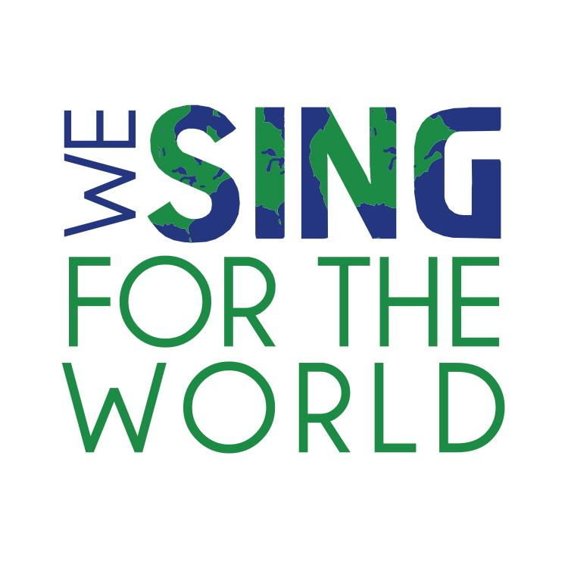
We Sing For The World
www.wesingfortheworld.com
info@wesingfortheworld.com
917.397.0475

_________________________________________________________________________________________________

For Immediate Release

The Make-A-Wish® Hudson Valley Foundation is an organization which grants the wishes of children with life threatening conditions. We Sing For The World became inspired by this organization and in the power of a wish and took on the task of creating the benefit concert “We Sing For Wishes” on December 10th at the White Plains Performing Arts Center in White Plains NY.

“Music is a powerful force that can bring people together and can make others heal”. Founder, Daniele Hager thought as she created We Sing For The World back in 2011 after the devastating tsunami that hit Japan back in March. Focusing on lesser know charities, disaster relief and even personal tragedies, the organization’s mission is to raise funds and awareness for those in need. We Sing For The World presents numerous benefit concerts in conjunction with various non-profit organizations featuring renown singers and musicians.

Proud to present our fourth concert “We Sing For Wishes” will be an event of Broadway favorites with Westchester’s own John Treacy Egan. John was last seen on the Broadway stage as Joey on “Sister Act”. John is an active performer both on the Broadway stage as well as with benefit concerts and cabarets. Other performers include: Founder Daniele Hager, Broadway performers, Robi Hager, Gabby Garza, Julia Harkey and Opera singers, Scottie Roché, and Johnny Hager. Special guests include: Westchester’s own Ben and Ross DeMarco, our youngest singer Molly DeLuca and a wish kid herself Bianca Muñiz. Bianca’s dream has always been to be a singer and performer. We are thrilled to have her be a part of this special event. The band includes: Music director, Eli Zoller, NYC musicians: Freddy Hall, Alex McCabe, John Hager, Tim Borecky and Marques Walls.

We Sing For Wishes is an event that will remind us that anyone can wish upon star. The concert will begin with Molly singing “When you wish upon a star” and will end with the full company singing “Make our garden grow”. The frame for the event makes us believe that we can make our dream grow if we just believe. Anyone can wish upon a star and Make-A-Wish makes these wishes come true for many children who believe. We want to help this cause, as we have all wished upon a star at some point in our lives.

We Sing For The World
in partnership with the White Plains Performing Arts Center

Present
“We Sing For Wishes”

a benefit concert for the Make-A-Wish® Hudson Valley Foundation
December 10th 2012

8:00 PM
at the White Plains Performing Arts Center
11 City Center, White Plains, NY

For tickets: www.wppac.com or at 914.328.1600

Tickets:
$20 advanced reservation
$15 student
$25 at the door

Join us for a night of Broadway Hits

Featuring: John Treacy Egan, Robi Hager, Gabby Garza, Johnny Hager, Julia Harkey, Scottie Roché and Daniele Hager, Eli Zoller, Marques Walls, Freddy Hall, Alex McCabe, John Hager and Tim Borecky

With special guests: Molly DeLuca, Bianca Muñiz, Ben and Ross DeMarco

